**Project Design Phase-II**

**Technology Stack (Architecture & Stack)**

|  |  |
| --- | --- |
| Date | 27 June 2025 |
| Team ID | LTVIP2025TMID40771 |
| Project Name | Traffictelligence |
| Maximum Marks | 4 Marks |

**Technical Architecture:**

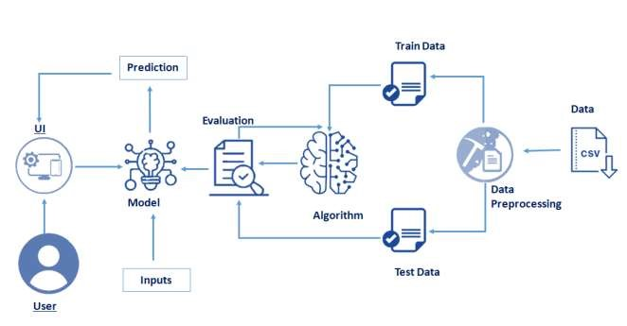

**Table-1 : Components & Technologies:**

|  |  |
| --- | --- |
| **Component** | Technology |
| **Web Framework** | **Flask** |
| Machine learning | **Scikit-learn, XGBoost** |
| Data preprocessing | **Pandas, numpy** |
| Model persistence | **Joblib** |
| Frontend | **Html, css** |
| Deployment | **Localhost(python)** |

**Table-2: Application Characteristics:**

|  |  |
| --- | --- |
| **Characteristic** | **Description** |
| Input | **User-entered weather, time, holiday data** |
| Processing | **Preprocessing with ColumnTransformer, scaling, prediction** |
| Output | **Predicted traffic volume (vehicles/hour)** |
| Scalability | **Single-server for now, expandable with cloud** |
| Security | **No user data storage, basic input validation** |

**References:**

* **Flask Documentation: https://flask.palletsprojects.com/**
* **Scikit-learn Documentation: https://scikit-learn.org/**